The source code for problem 4 can be found in the file Traversals.py.

For this graph the output of connected_components(graph) is:

1. 0 3 4 2 5 1

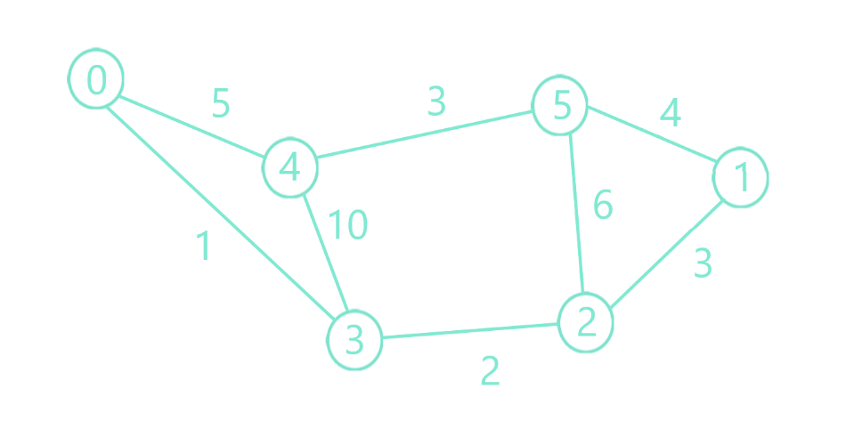

Component 1

Visited at start: [0]

Queue at start: [3, 4]

Step 1:

Vertex: 3 and Current position in queue: 0

Visited before parsing outbound vertices: [0]

Queue before parsing outbound vertices: [3, 4]

Visited after parsing outbound vertices: [0, 3]

Queue after parsing outbound vertices: [3, 4, 0, 2, 4]

Step 2:

Vertex: 4 and Current position in queue: 1

Visited before parsing outbound vertices: [0, 3]

Queue before parsing outbound vertices: [3, 4, 0, 2, 4]

Visited after parsing outbound vertices: [0, 3, 4]

Queue after parsing outbound vertices: [3, 4, 0, 2, 4, 0, 3, 5]

Step 3:

Vertex: 2 and Current position in queue: 3

Visited before parsing outbound vertices: [0, 3, 4]

Queue before parsing outbound vertices: [3, 4, 0, 2, 4, 0, 3, 5]

Visited after parsing outbound vertices: [0, 3, 4, 2]

Queue after parsing outbound vertices: [3, 4, 0, 2, 4, 0, 3, 5, 1, 3, 5]

Step 4:

Vertex: 5 and Current position in queue: 7

Visited before parsing outbound vertices: [0, 3, 4, 2]

Queue before parsing outbound vertices: [3, 4, 0, 2, 4, 0, 3, 5, 1, 3, 5]

Visited after parsing outbound vertices: [0, 3, 4, 2, 5]

Queue after parsing outbound vertices: [3, 4, 0, 2, 4, 0, 3, 5, 1, 3, 5, 1, 2, 4]

Step 5:

Vertex: 1 and Current position in queue: 8

Visited before parsing outbound vertices: [0, 3, 4, 2, 5]

Queue before parsing outbound vertices: [3, 4, 0, 2, 4, 0, 3, 5, 1, 3, 5, 1, 2, 4]

Visited after parsing outbound vertices: [0, 3, 4, 2, 5, 1]

Queue after parsing outbound vertices: [3, 4, 0, 2, 4, 0, 3, 5, 1, 3, 5, 1, 2, 4, 2, 5]

For this graph the output of connected_components(graph) is:

1. 0

2. 1 2 3 4

3. 5 6 7 8

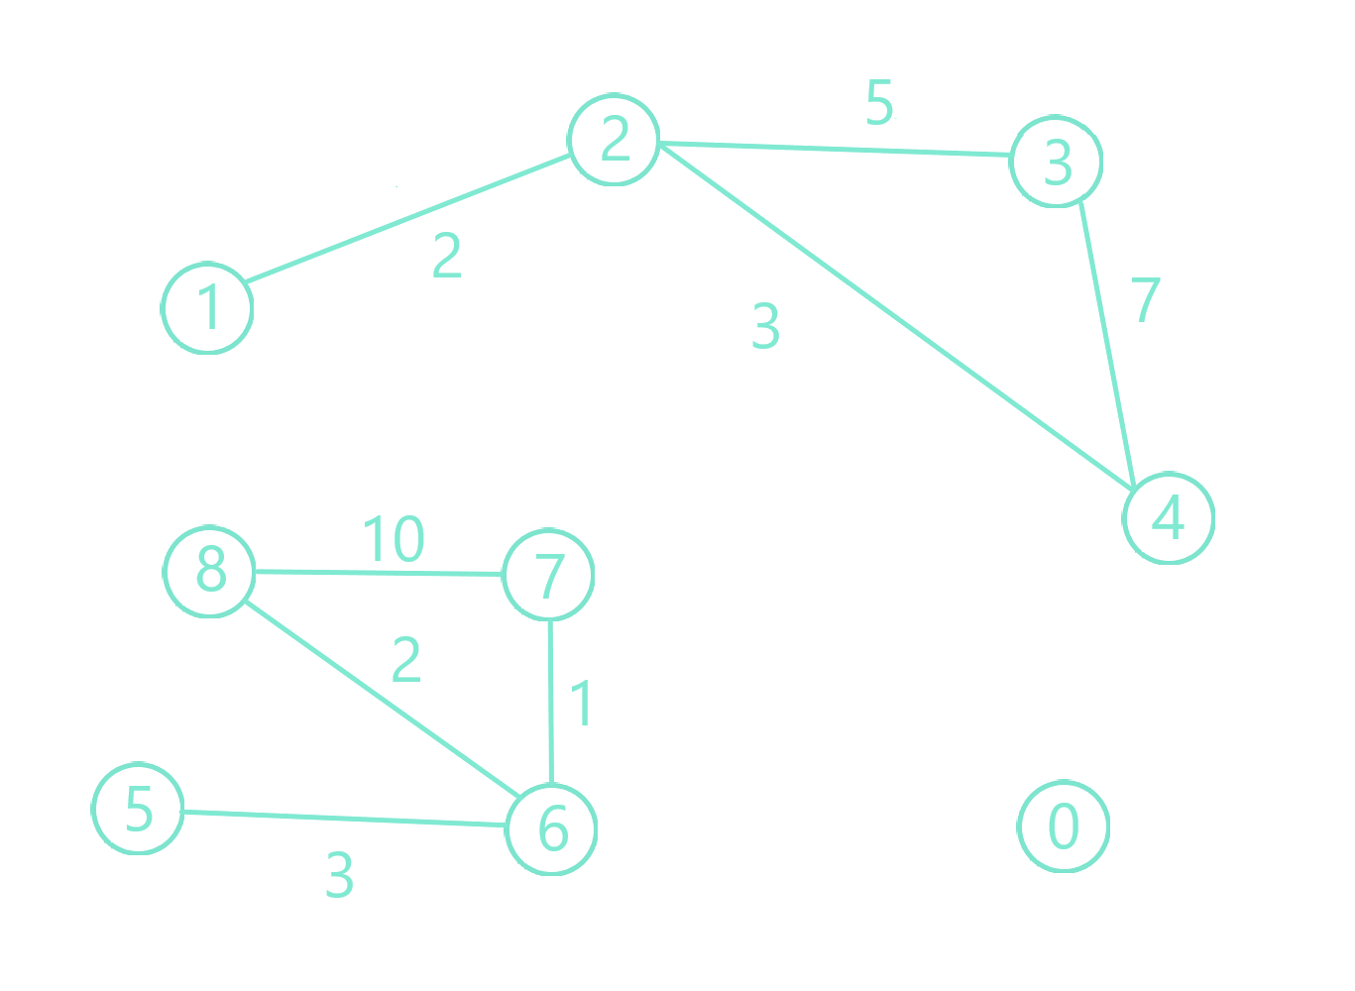

Component 1

Visited at start: [0]

Queue at start: []

Component 2

Visited at start: [1]

Queue at start: [2]

Step 1:

Vertex: 2 and Current position in queue: 0

Visited before parsing outbound vertices: [1]

Queue before parsing outbound vertices: [2]

Visited after parsing outbound vertices: [1, 2]

Queue after parsing outbound vertices: [2, 1, 3, 4]

Step 2:

Vertex: 3 and Current position in queue: 2

Visited before parsing outbound vertices: [1, 2]

Queue before parsing outbound vertices: [2, 1, 3, 4]

Visited after parsing outbound vertices: [1, 2, 3]

Queue after parsing outbound vertices: [2, 1, 3, 4, 2, 4]

Step 3:

Vertex: 4 and Current position in queue: 3

Visited before parsing outbound vertices: [1, 2, 3]

Queue before parsing outbound vertices: [2, 1, 3, 4, 2, 4]

Visited after parsing outbound vertices: [1, 2, 3, 4]

Queue after parsing outbound vertices: [2, 1, 3, 4, 2, 4, 2, 3]

Component 3

Visited at start: [5]

Queue at start: [6]

Step 1:

Vertex: 6 and Current position in queue: 0

Visited before parsing outbound vertices: [5]

Queue before parsing outbound vertices: [6]

Visited after parsing outbound vertices: [5, 6]

Queue after parsing outbound vertices: [6, 5, 7, 8]

Step 2:

Vertex: 7 and Current position in queue: 2

Visited before parsing outbound vertices: [5, 6]

Queue before parsing outbound vertices: [6, 5, 7, 8]

Visited after parsing outbound vertices: [5, 6, 7]

Queue after parsing outbound vertices: [6, 5, 7, 8, 6, 8]

Step 3:

Vertex: 8 and Current position in queue: 3

Visited before parsing outbound vertices: [5, 6, 7]

Queue before parsing outbound vertices: [6, 5, 7, 8, 6, 8]

Visited after parsing outbound vertices: [5, 6, 7, 8]

Queue after parsing outbound vertices: [6, 5, 7, 8, 6, 8, 6, 7]